

TOM
Outline Architecture

Finance Package F012 – OFi Vendor Interface to ORMS Supplier

Version: | 1.2.2
Author: | Thomas Harper
Date: | 12.02.2007

Version: | 1.2.2
Author: | Thomas Harper
Date: | 12.02.2007
Project BEN Code: | W60416
Circulation Restrictions: | Tesco Internal Only
Status: | Ready for Review

Document Information

Change Record

Author | Date | Version | Change Reference, description
Thomas Harper | 23/01/2007 | 1.0.0 | Draft
Thomas Harper | 30/01/2007 | 1.1.0 | Incorporated OFi flexfield changes. Highlighted mapping assumptions.
Thomas Harper | 31/01/2007 | 1.2.0 | Finalised assumptions
Thomas Harper | 01/02/2007 | 1.2.1 | Added missing LAST_NAME field
Thomas Harper | 12/02/2007 | 1.2.2 | Changed input file to pipeline delimited

Reviewers

Name | Date | Version | Role
Sidd Sarangi |  |  | Business Analyst
Nigel Glenn |  |  | Enterprise Architect
Nathan Smith |  |  | Enterprise Architect
David Onyett |  |  | Project Leader
Jonathan Brimley |  |  | IBM Consultant, USA

Distribution

Name | Role
Nigel Glenn | Enterprise Architect
 | Solution Architect
Nathan Smith | Enterprise Architect
Ann Merritt | Enterprise Architect
Duncan Wellberry | TOM Programme Manager
Rae Topp | TOM Integration Project Manager
David Onyett | TOM Integration Project Manager
David Briggs | Group IT Distribution and Head Office Systems Portfolio Manager
Jonathan Brimley | IBM Consultant, USA
Sidd Sarangi | Business Analyst

References
All documents are held in Sharepoint.
Document | Where held | Version & date
Solutions Architecture | Not Available
Business Requirements Document | Not Available
Project Technical Systems Design | Not Available
Funding Project Plan
Integration Context Diagram.vsd | TOM Vendors to ORMS Supplier Integration Context Dgm v1.1.vsd  page: VENDORS via Biztalk
IS Order Spec - Transformation of Oracle Finance Supplier to ORMS exploded Supplier xml | to be developed

Sign-Off
By signing this form, I understand and agree with the contents of this document.

Business Owner/Customer | David Briggs
Role | Funding IT Programme Manager
Signature
Date

Table of Contents
Table of Contents iv
1. Introduction 5
1.1. Purpose 5
1.2. Background 5
1.3. Scope 7
1.3.1. In Scope 7
1.3.2. Out of Scope 7
2. TOM Project high-level requirements 7
3. Information Architecture High Level Design 7
3.1. The scope of this Integration Design covers 7
3.2. Interfaces 7
3.3. Context Architecture 8
4. Oracle Extraction Requirements (Application Project) 9
4.1. Switch Off BPEL SendVendorToOracle Retail processing (Application Project) 9
4.2. Extract File (Application Project) 9
4.3. File Transmission (Application Project) 9
4.4. Post Transmission Cleanup Script (Application Project) 9
5. Information Services Requirements 9
5.1. Interfaces (TOM Integration Project) 10
5.1.1. 10
5.2. Data Requirements 10
6. Physical Deployment 10
7. Benefits and concerns 10
7.1. Benefits/key features 10
7.2. Concerns/risks 10
8. Deliverables and high-level Estimate 11
Appendix A Data Definitions and Mappings 14
A.1 OFi Extracted Record Format 14
Fields should be pileline ‘|’ delimited. 14
Records should end with CR. 15
A.2 Common Form Schema 18
A.3 OFi Source Data 18
A.4 RIB RMS message format 31
A.5 Mapping 15

Introduction

The Oracle Vendor interface isn’t fit for Tesco use. The BPEL changes needed to make it fit for purpose won’t be ready in time for go live. We will develop our own interim solution with the following caveats and assumptions

HIGH LEVEL ASSUMPTIONS

- IN the ABSENCE of a SOLUTION ARCHITECTURE DOCUMENT:-
  - Vendor Site information will be extracted from OFi to a flat file
  - Extracts from Oracle Financials will be updated records only (i.e first time through we get the lot, afterwards only changes)
  - Extraction is repeated hourly due to Supplier suspension requirements

- IN the ABSENCE of a PROJECT TECHNICAL DESIGN:-
  - The Information in Oracle manuals is sufficient to carry out the integration
  - A Common Form schema for Supplier is available and is fit for purpose
  - Values held in certain fields will map directly between applications e.g. Country.

Purpose
This document describes the TOM Programme’s high level requirements for a Vendor to Supplier interface between Oracle Financials (OFi) and Oracle Retail Merchandise System (ORMS)
From these requirements the document proposes an Integration design and lists key involvements. This will provide information to the application project, the Integration development and the TOM programme plan.

Background
The TOM Project is to implement repeatable Group based solutions mainly centred on Oracle Applications. Integration is required between these packages where the integration is either not yet completed by Oracle or the Oracle integration does not meet Tesco requirements.
The Integration deliverables for Oracle Finance (OFi) replace the Oracle provided integration between OFi and ORMS and OFi and ReIM where the manufacturers solution is not fit for Tesco purpose.
ORMS Supplier setup will be controlled from OFi by sending Vendor information to ORMS.
The OFi Vendor table holds the Vendor as a Master Record with child Vendor Site Addresses. If transferred directly to ORMS using the “out of the box” integration only the first address would ever be referenced as the Supplier. To overcome this difference it is necessary to “explode” the Financials Record such that there will be a main Supplier Record in ORMS corresponding to each Vendor Supplier Address as held in the Supplier_Site data flex field (DFF) in Financials.

The Vendor Address Supplier_Site DFF (ATTRIBUTE10) value will be used as the ORMS Supplier Key . The Vendor Id is held in SEGMENT1.

Master Vendor
Vendor Site 1
Vendor Site 2
Vendor Site 3
ORMS
FINANCIALS
Supplier 1
Supplier 2
Supplier 3
PO_VENDOR_SITES_ALL
PO_VENDORS
SUP

Note that the change means that the 5 digit PO_VENDORS_SITES_ALL.Attribute10 in Financials becomes the 5 digit SUP.SUPPLIER in ORMS.

For PO_vendors table, the "supplier number" data is stored in the Segment1 field. For the PO_vendors_sites_all table, the "vendor site dff " is Attribute10.

The Vendor and Vendor sites will also have a mandatory flex field ‘Costing Date’ with options ‘Order Date’ & ‘Delivery Date’. This information will be defaulted to Vendor sites from the Vendor level but can be changed at site level. This data will be interfaced to the ORMS supplier.
[assumption – this is yet to be confirmed and detailed]
ORWMS
Store Systems
Store Systems
8
Storeline
10
ORWMS
5
GFO
10
RMS
30
OFI
Supplier Id Size
System
Supplier Id
Raw Sales
Supplier Id,
Receipts
Master
Supplier
Supplier
Supplier 1
Supplier
Supplier 3
Supplier
Supplier 2
Supplier 1
Supplier 2
Supplier 3
Trait
Master

Scope

In Scope

Integration of Oracle Vendors to ORMS Suppliers
Persisting of Supplier data in the Integration Data Store (IDS) in the Integration Layer

Out of Scope

All Other OFi to ORMS and ReIM Interfaces

TOM Project high-level requirements

Information Architecture High Level Design

The scope of this Integration Design covers

- Extract Vendor and Vendor Adress data from OFI using a script to create a flat file
- Transmit extracted file from Oracle Financials to Biztalk using XCOM[Assumption]
- File Receive into Biztalk using RTI Adapter[Assumption]
- Debatch Flat file
- Transform Flat file to Supplier Common Format XML message
- Create copy of Common Form
- Transform Common format to RIB format Supplier XML message
- Use Sysrepublic Real Time Integrator JMS adapter to publish Supplier messages to the Supplier JMS Topic on the Retek Integration Bus (RIB)
- Write the copies of the Common Format messages to a file share for IDS Import via SSIS

Interfaces
There is 1 interface between Oracle Financials and ORMS, as shown on the next page. Reference:
Context Diagram: Supplier to ORMS from Oracle Financials
Page Name: Vendor via Biztalk

Context Architecture
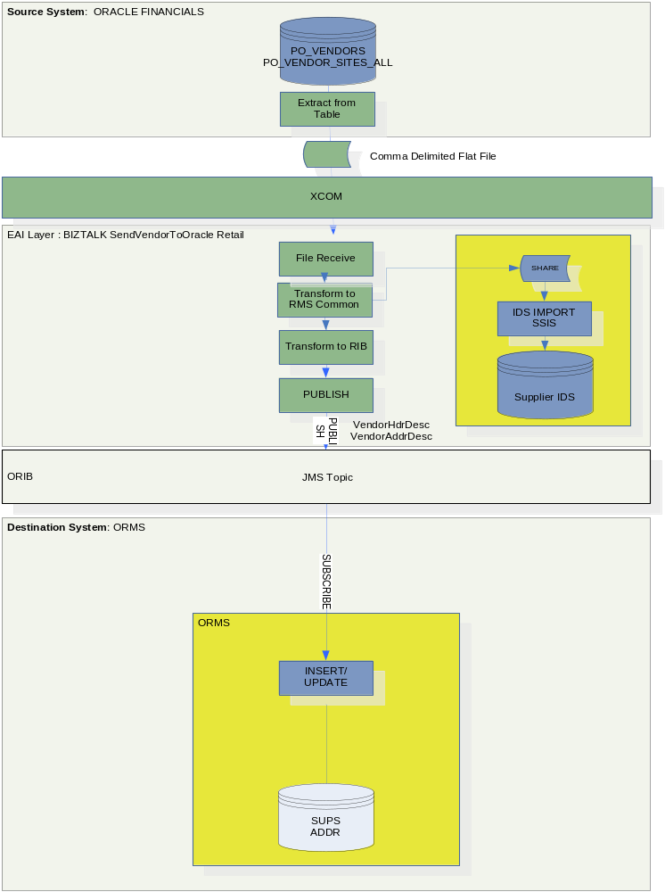
Interface 1: Oracle Financials Supplier to ORMS Supplier
Oracle Financials sends an extracted Supplier flat file to a Biztalk File Receive location. Biztalk converts the file to a Common Form then to RIB format and loads it to ORMS via the RIB. A SQL Supplier database in the Integration Layer will also be loaded using the Common Form during this process.

Oracle Extraction Requirements (Application Project)
The Extraction Process and Transmission will be specified and coded by the Application Project [Assumption].

Switch Off BPEL SendVendorToOracle Retail processing (Application Project)

Extract File (Application Project)
Only certain supplier sites are needed for ORMS. Only records with the Flex Field ORMS_FLAG [name assumption] set to “YES” [value assumption] will be extracted.
The Vendor (PO_VENDOR table) and Vendor Sites (PO_Vendor_Sites_All) records will be extracted using an inner join to create a combined record for each Vendor Site together with contact details from Vendor Contacts (PO_Vendor_Contacts).
The combined records will hold information from the appropriate fields from the Vendor master and from each child Vendor Site and Associated Contact information.
“For PO_vendors table, the "supplier number" data is stored in the Segment1 field. For the PO_vendors_sites_all table, the "vendor site dff " is Attribute10.”
The extracted records will therefore use the data in Segment1 to provide the number for the Vendor id and will use Attribute10 to provide the number for the Vendor Site Id
The extracted records will constitute a flat file.
Fields will be pileline ‘|’ delimited.
CR will delimit end of record.
The extraction will be scheduled for an hourly [Assumption] transmission. (If Vendors are suspended we will want the information propogated fairly rapidly).
The extract will comprise all records changed since the last extract.

File Transmission (Application Project)
The file will be transmitted to a Biztalk File Receive location.
The transmission technology will be XCOM [Assumption]
An hourly [Assumption] schedule will be set up to run the transmission.

Post Transmission Cleanup Script (Application Project)
Upon successful transmission the file will be moved to an archive folder to prevent retransmission

Information Services Requirements
The Integration Interface Specification, the Mapping Spreadsheet and the coding of the Interface will be carried out by the Tom Integration Project.

Interfaces (TOM Integration Project)
The interface will be implemented on the BizTalk 2006 platform.
The following interface makes up the TOM Integration Project interface package:

A Biztalk Orchestration Receives the extracted flat file into a Pipeline where it is debatched.
The Orchestration transforms each flat file record into a Supplier Common form XML message.
A parallel process is created to make a copy of the Common Form and to write it to a file share where it will be received by an IDS Import Process.
(Note: The Supplier IDS is for use by other systems that need supplier information. It will also be used by the Approved Payments interface so that the messages coming from ReIM to OFi can have the Supplier_Id overwriiten with the Vendor Number Vendor_Id by means of a SQL lookup functoid).
The Common Form is Transformed into a RIB format message
The message is Published onto the RIB by the Sysrepublic RTI Adapter.
An MSI for this Interface will be configured and generated for deployment purposes

Data Requirements
See the Appendix for data requirements.

Physical Deployment
The interface will be deployed into a standard Tesco EAI BizTalk 2006 environment using an MSI process.

A Release Note will document the installation process.

Benefits and concerns

Benefits/key features
The new interface will be implemented on the strategic BizTalk 2006 platform, replacing the Oracle provided Integration with an Integration that meets Tesco requirements.

Concerns/risks
At the time of writing

- There is no Solutions Architecture feeding into this design
- There is no Project Technical Design feeding into this design
- The BizTalk 2006 environment is new for Tesco, and the design / development / operational processes are not as mature as for the BizTalk 2002 environment
- It is as yet not known who will be developing the Oracle extraction code..

Deliverables and high-level Estimate
The column marked Gen/Spec shows whether the build is generic (G), e.g. reusable by other projects, or specific (S) to this project.

Activity | Interface | Required by for Integration Test | Complexity | Dev/UT Estimate (Days) | Gen/Spec | Comments
1 | Program Specification for theOracle Extract | 28/03/2007 | L | 1 | S | 1. Must include layout for extracted records  2. Must specify that a record is output for each child site address. (This can be done using an inner JOIN for the site address in the SELECT statement). Only one set of contact details will be forwarded to ORMS. Where this is held in the Vendor_Contacts table only the first contact will be used.  3. As we are selecting changes the select statement should include something like:- “where table VENDORS. LAST_UPDATE_DATE > sysdate-1 (for updates today) or VENDORS. LAST_UPDATE_DATE > date/time of start of last extract run.”  4. Only select where flex field ORMS_FLAG for orms is set to “YES”.  For PO_vendors table, the "supplier number" data is stored in the Segment1 field. For the PO_vendors_sites_all table, the "vendor site dff " is Attribute10.
2 | Oracle Extract Script | 28/03/2007 | L | 1 | S | Extract Vendors and Vendor Sites Output a combined record for every site as a pileline ‘|’ delimited flat file.
3 | Schedule Extracts | 28/03/2007 | L | 0.5 | S | Configure the scheduler to run the extract at specified time intervals
4 | Switch off BPEL process SendVendorToOracle Retail | 28/03/2007 | L | 0.5 | S | We don’t want to send Vendor updates via the manufacturer’s provided interface
5 | Transmit the File | 28/03/2007 | L | 0.5 | S | Configure XCOM
6 | Schedule the Transmission | 28/03/2007 | L | 0.5 | S | Configure the scheduler for the Transmission
7 | Post Transmission Clean Up Script | 28/03/2007 | L | 1 | S | Move the transmitted file to an archive location
8 | Mapping Spreadsheet | 28/03/2007 | M | 1 | S | Specify transformation rules
9 | Interface Specification |  | M | 2 | S | Specify the Interface
10 | Extend Common Form to Support this Interface’s requirements | 28/03/2007 | M | 2 | G | Extend Supplier Common Form
11 | Flat File Schema | 28/03/2007 | M | 1 | S | Specify the schema for the incoming flat file
12 | Maps | 28/03/2007 | M | 1 | S | Create Maps for Flat File to Common and Common to RIB
13 | Biztalk Interface  Financials Vendor and Sites to ORMS Supplier and to IDS Supplier | 28/03/2007 | H | 7 | G | Receives file  Maps Supplier Vendor+Site records into separate Suppliers for ORMS (output is to Common RMS Supplier Message Schema).  Set up parallel flow. On first output the record to a share for IDS Import Processing. On the second, pass the common msg to a transform to RIB process.  Pass the message to the RTI Adapter to publish to the RIB.  Platform BizTalk 2006
14 | Interface MSI | 28/03/2007 | M | 3 | S | Build the Deployment MSI for the Biztalk Assemblies
15 | Release Note | 28/03/2007 | M | 2 | S | Specifies the Release Processes
- Data Definitions and Mappings
These data requirements are derived from :-
Oracle Accounts Payable Technical Reference manual
ORMS Data Dictionary manual
Oracle Retail RMS-Oracle Financials Implementation Guide manual
RIB Mapping Report Release 12.0.0 manual
ORMS Data Dictionary manual
It should be noted that there is no Project Technical Reference Document for this interface.
  - OFi Extracted Record Fields
TABLE | FIELD NAME | TYPE
PO_VENDORS | VENDOR_ID (from table key) | 6 NUMBER
PO_VENDORS | VENDOR NUMBER VENDOR_ID (from SEGMENT1 field) | 6 NUMBER
PO_VENDOR_SITES_ALL | VENDOR_SITE_ID (from Table key) | 5 NUMBER
PO_VENDOR_SITES_ALL | VENDOR_SITE_ID (from ATTRIBUTE10 field)) | 5 NUMBER
PO_VENDORS | VENDOR_NAME | 80 VARCHAR2
PO_VENDORS????? | VENDOR_STATUS * | “A” or “I”
PO_VENDOR_CONTACTS | FIRST_NAME | 15 VARCHAR2
PO_VENDOR_CONTACTS | MIDDLE_NAME | 15 VARCHAR2
PO_VENDOR_CONTACTS | LAST_NAME
PO_VENDOR_SITES_ALL | PAYMENT_CURRENCY_CODE  OR INVOICE_CURRENCY_CODE *** | 15 VARCHAR2
PO_VENDOR_SITES_ALL | LANGUAGE *** | 30 VARCHAR2
PO_VENDOR_SITES_ALL | TERMS_ID *** | NUMBER
PO_VENDOR_SITES_ALL | FREIGHT_TERMS_LOOKUP_CODE *** | 25 VARCHAR2
PO_VENDOR_SITES_ALL | FIRST_NAME | 15 VARCHAR2
PO_VENDOR_SITES_ALL | MIDDLE_NAME | 15 VARCHAR2
PO_VENDOR_CONTACTS | LAST_NAME | 20 VARCHAR2
PO_VENDOR_SITES_ALL | ADDRESS_LINE1 | 35 VARCHAR2
PO_VENDOR_SITES_ALL | ADDRESS_LINE2 | 35 VARCHAR2
PO_VENDOR_SITES_ALL | ADDRESS_LINE3 | 35 VARCHAR2
PO_VENDOR_SITES_ALL | CITY | 25 VARCHAR2
PO_VENDOR_SITES_ALL | STATE | 25 VARCHAR2
PO_VENDOR_SITES_ALL | COUNTRY | 25 VARCHAR2
PO_VENDOR_SITES_ALL | ZIP | 20 VARCHAR2
PO_VENDOR_SITES_ALL | PHONE | 15 VARCHAR2
PO_VENDOR_SITES_ALL | FAX | 15 VARCHAR2
PO_VENDOR_SITES_ALL | SITE_TYPE ** | “04” or “06”
? | EMAIL | 100 VARCHAR2
? | from Flexfield ‘Costing Date’ with options ‘Order Date’ and ‘Delivery Date’ **** | ?
* The extract script should set the status to “I” or “A” based on the supplier status.
** The extract script should set the site type to “04” or “06” based on the type of site.
*** Payment Currency, language, terms_id, freight terms and country will be mapped directly across [assumption – same codes are used across the applications]
**** Awaiting further details from Sidd

Fields should be pileline ‘|’ delimited.
Records should end with CR.
  - End to End Mapping
The table below shows end to end what we are trying to achieve with this interface and is based on the out of the box interface. Mapping will be achieved via an intermediate conversion to the Supplier Common Form. I.e. Flat file MapTo CommonForm and CommonForm MapTo RIB VendorHdrDesc and VendorAddrDesc [and OracleOUDesc(?) and OUDtlDesc(?).]

This is shown in the mapping Spreadsheet.
SYSTEM | TABLE | FIELD NAME | TYPE | SYSTEM | TABLE | FIELD NAME | TYPE | NOTES
OFI | PO_VENDORS | VENDOR NUMBER “VENDOR_ID” (from SEGMENT1) | 6 NUMBER |  |  |  |  | Held in IDS
OFI | PO_VENDOR_SITES_ALL | “VENDOR_SITE_ID” (from ATTRIBUTE10) | 5 NUMBER | ORMS | SUPS | SUPPLIER | 5 Number | KEY
 | PO_VENDORS | VENDOR_NAME | 80 VARCHAR |  | SUPS | SUP_NAME | 240 VARCHAR | PAD
 | PO_VENDOR_CONTACTS | FIRST_NAME + MIDDLE NAME + LAST NAME | 15 + 15 +25 |  | SUPS | CONTACT_NAME | 120 VARCHAR2 | ONLY FIRST OCCURENCE
 | PO_VENDOR_SITES_ALL | PHONE | 15 VARCHAR2 |  | SUPS | CONTACT_PHONE | 20 VARCHAR2 | PAD
 | ? | ? |  |  | SUPS | CONTACT_PAGER
 | ? | Extract script should set to “I” or “A” |  |  | SUPS | SUP_STATUS | 1 VARCHAR2 | ‘A’ OR ‘I’
 | PO_VENDOR_SITES_ALL | PAYMENT_CURRENCY_CODE  OR INVOICE_CURRENCY_CODE | 15 VARCHAR2 |  | SUPS | CURRENCY_CODE  FK to FND_CURRENCIES.CURRENCY_CODE | 3 VARCHAR2 | ASUMPTION [both systems are using the same 3 digit code)
 | PO_VENDOR_SITES_ALL | LANGUAGE | 30 VARCHAR2 |  | SUPS | LANG FK to LANG LANG.DESCRIPTION VARCHAR2(120) | 6 NUMBER | [ASSUMPTION]  THESE WILL BE THE SAME FORMAT
 | PO_VENDOR_SITES_ALL | TERMS_ID | NUMBER |  | SUPS | TERMS FK TERMS_HEAD.TERMS | 15 VARCHAR2 | [ASSUMPTION]  THESE WILL BE THE SAME FORMAT
 | PO_VENDOR_SITES_ALL | FREIGHT_TERMS_LOOKUP_CODE | 25 VARCHAR2 |  | SUPS | FREIGHT_TERMS | 30 VARCHAR2 | [ASSUMPTION]  THESE WILL BE THE SAME FORMAT
 | ? | ? |  |  |  | CONTACT_EMAIL | 100 VARCHAR2 | Default=”UNKNOWN”
 |  | generated |  |  | ADDR | MODULE | 4 VARCHAR2 | ‘SUPP’
 | PO_VENDOR_SITES_ALL | VENDOR_SITE_ID (ATTRIBUTE10) | 5 NUMBER |  | ADDR | KEY_VALUE_1 | 5 NUMBER
 |  |  |  |  | ADDR | SEQ_NO | NUMBER(4,0) | GENERATED
 | PO_VENDOR_SITES_ALL | “site type” = the extraction script needs to determine this and set the value to a 04 or a 06 | 2 VARCHAR2 |  | ADDR | ADDR_TYPE | 2 VARCHAR2  “04” OR “06” | 01 =Busines  02= Postal  03=Returns  04=Order  05=Invoice  06=Remittance
 |  |  |  |  | ADDR | PRIMARY_ADDR_IND
 | PO_VENDOR_SITES_ALL | ADDRESS_LINE1 | 35 VARCHAR2 |  | ADDR | ADD_1 | 240 VARCHAR2 | PAD
 | PO_VENDOR_SITES_ALL | ADDRESS_LINE2 | 35 VARCHAR2 |  | ADDR | ADD_2 | 240 VARCHAR2 | PAD
 | PO_VENDOR_SITES_ALL | ADDRESS_LINE3 | 35 VARCHAR2 |  | ADDR | ADD_3 | 240 VARCHAR2 | PAD
 | PO_VENDOR_SITES_ALL | CITY | 25 VARCHAR2 |  | ADDR | CITY | 120 VARCHAR2 | PAD
 | PO_VENDOR_SITES_ALL | STATE | 25 VARCHAR2 |  | ADDR | STATE | 3 VARCHAR2 | TRUNCATE
 | PO_VENDOR_SITES_ALL | ZIP | 20 VARCHAR2 |  | ADDR | POST | 30 VARCHAR2 | PAD
 | PO_VENDOR_SITES_ALL | COUNTRY | 25 VARCHAR2 |  | ADDR | COUNTRY_ID | 3 VARCHAR2 | [ASSUMPTION]  ORACLE IS USING A 3 DIGIT ISO CODE FOR COUNTRY
 | PO_VENDOR_CONTACTS | FIRST_NAME + “ “ + Middle_name + “ “ + LastName | 15+15+25 |  | ADDR | CONTACT_NAME | 120 VARCHAR2 | Default=”UNKNOWN”
 | PO_VENDOR_SITES_ALL | PHONE | 15 VARCHAR2 |  | ADDR | CONTACT_PHONE | 20 VARCHAR2 | PAD
 | PO_VENDOR_SITES_ALL | FAX | 15 VARCHAR2 |  | ADDR | CONTACT_FAX | 20 VARCHAR2 | PAD
 | PO_VENDOR_SITES_ALL | VENDOR_SITE_ID (FROM ATTRIBUTE10) | 5 NUMBER |  | ADDR | ORACLE_VENDOR_SITE_ID | 5 NUMBER

Mapping – Flat File to Common Form
See Mapping Spreadsheet

Mapping – Common Form to RIB
See Mapping Spreadsheet

Common Form Schema
[Placeholder – this is being worked on]
See http://docshare/UK%20IT/TOM%20Integration /????????????????

  - OFi Source Data
For up to date information See
Accounts Payable Technical Reference Manual (aptrm.pdf) :-
Table and View definitions -
PO_Vendors
PO_Vendor_Sites_All
PO_Vendor_Contacts
These are copied below for convenience.
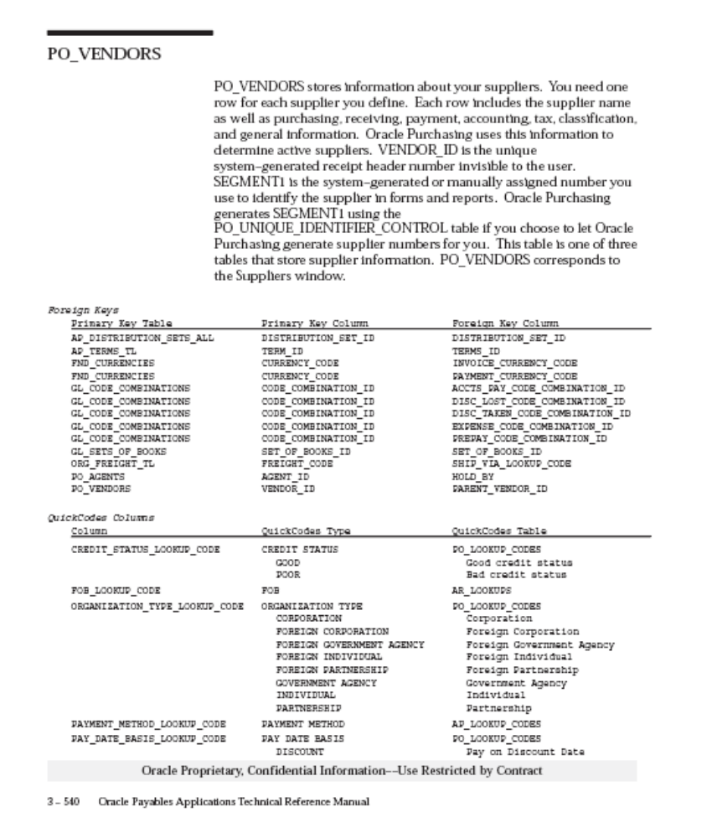
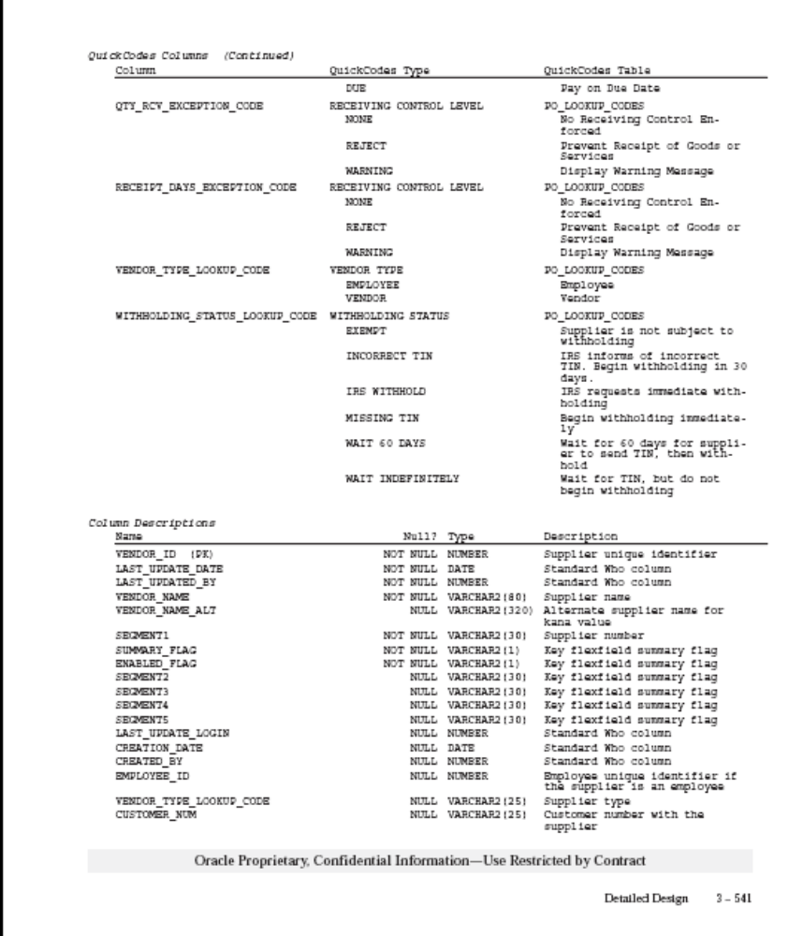
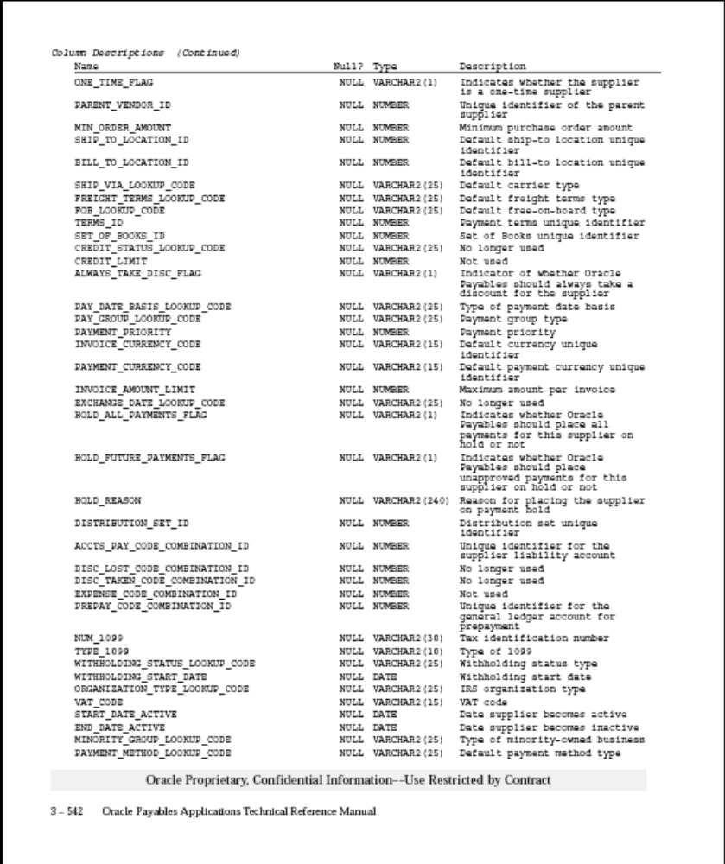

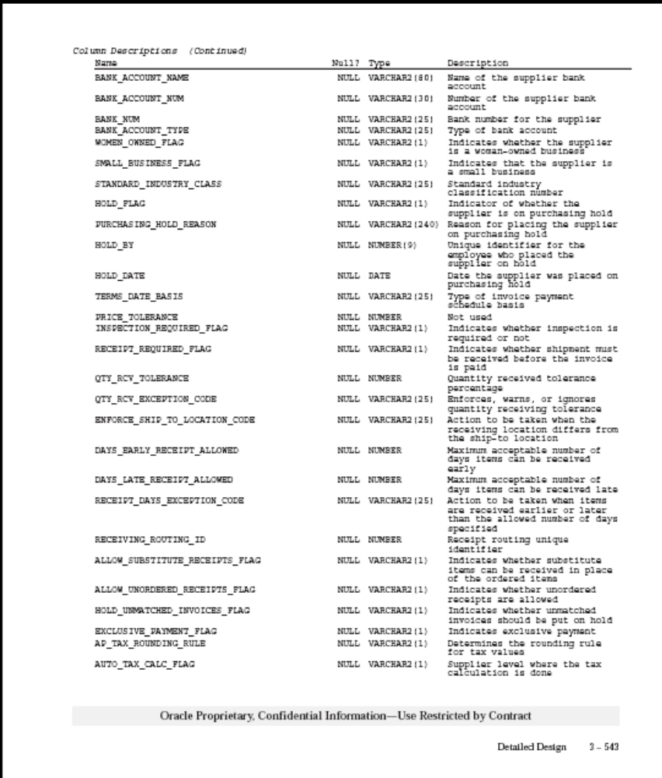

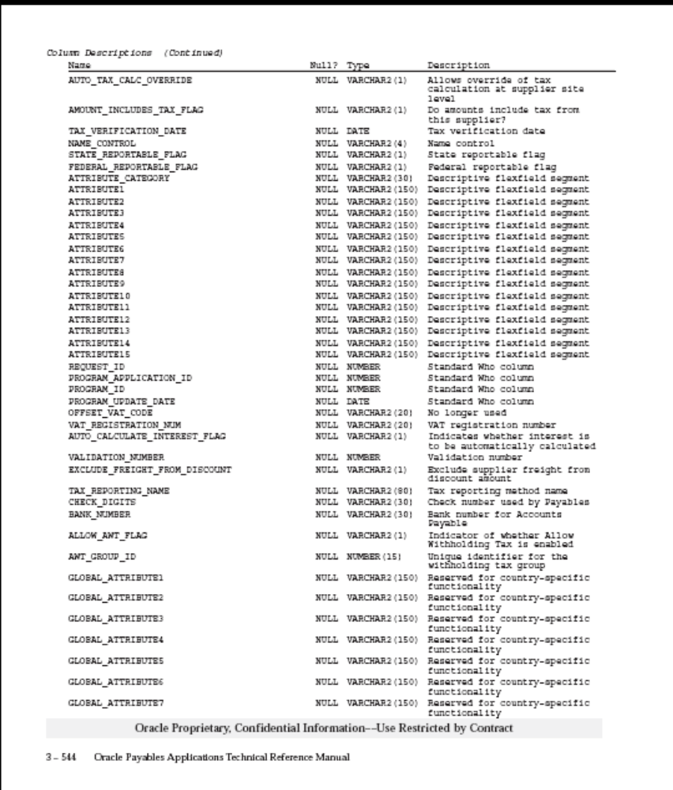
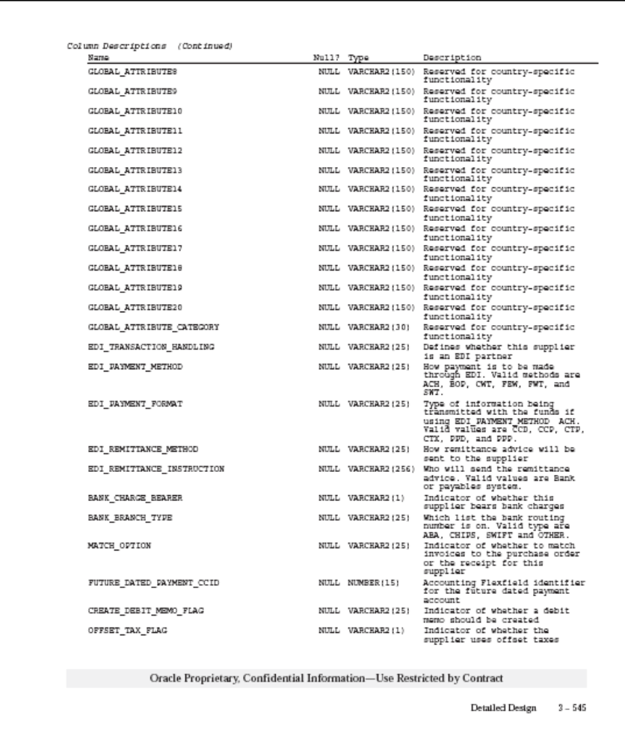
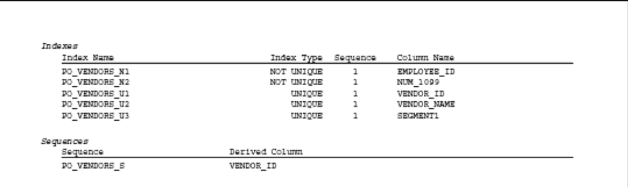

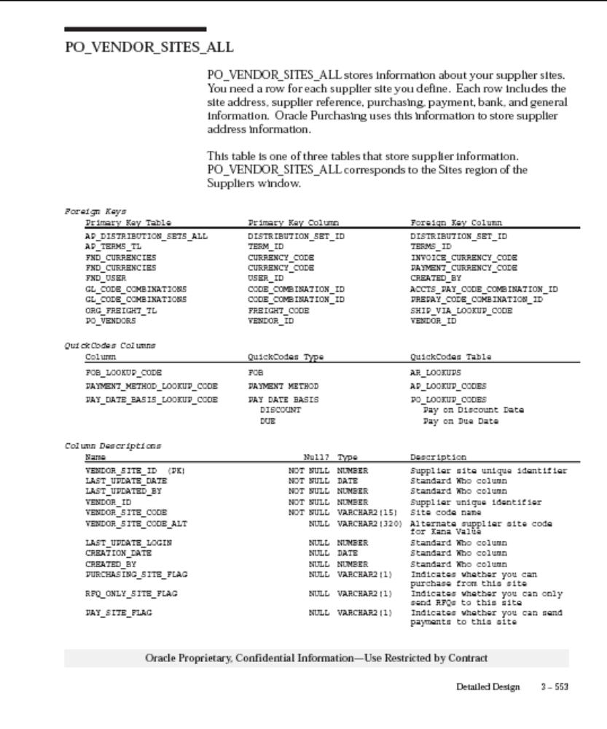
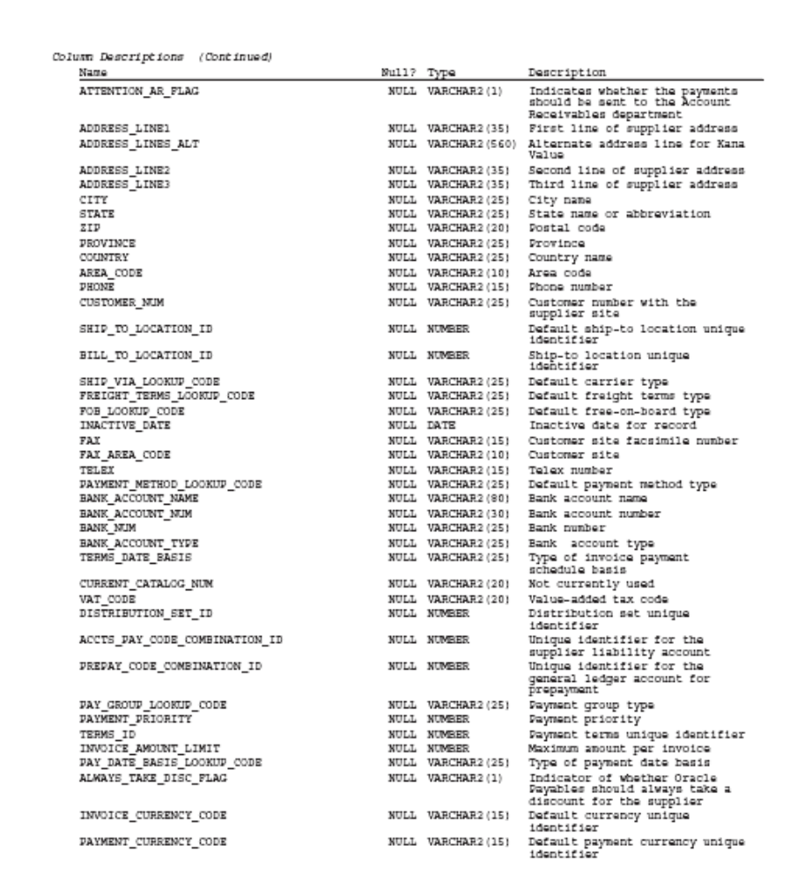

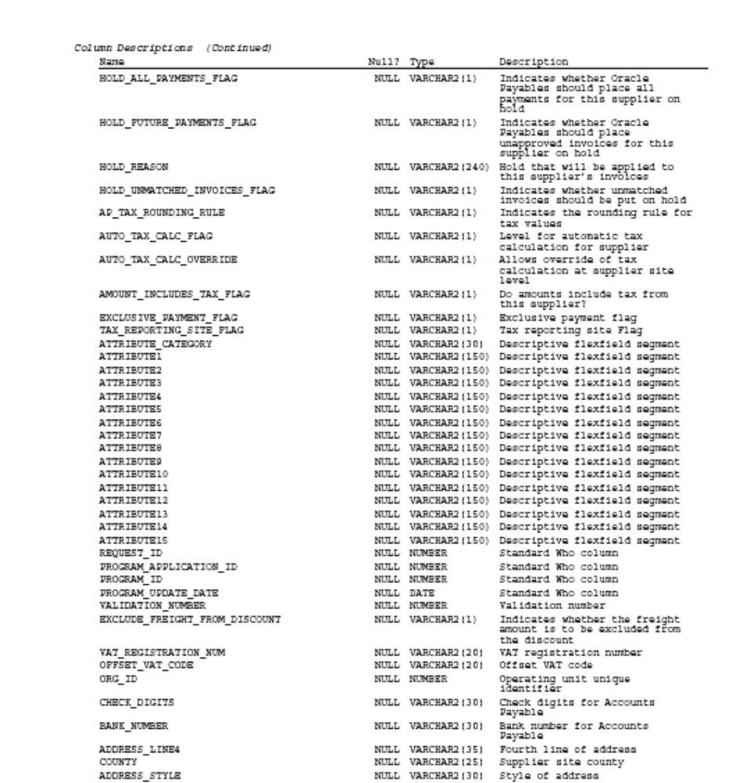

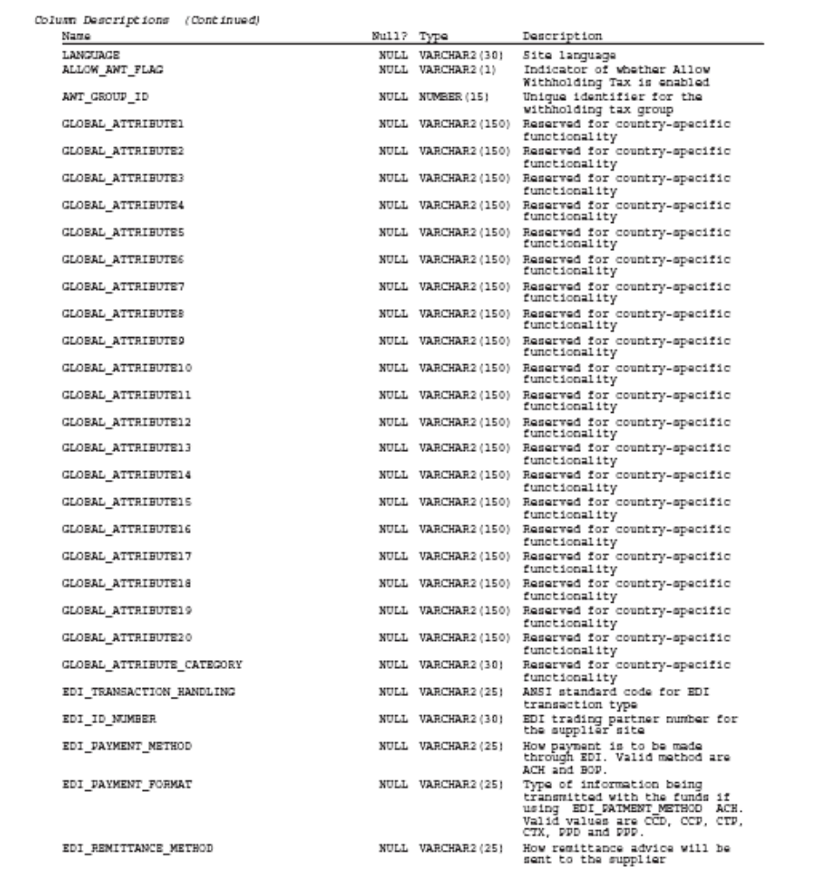

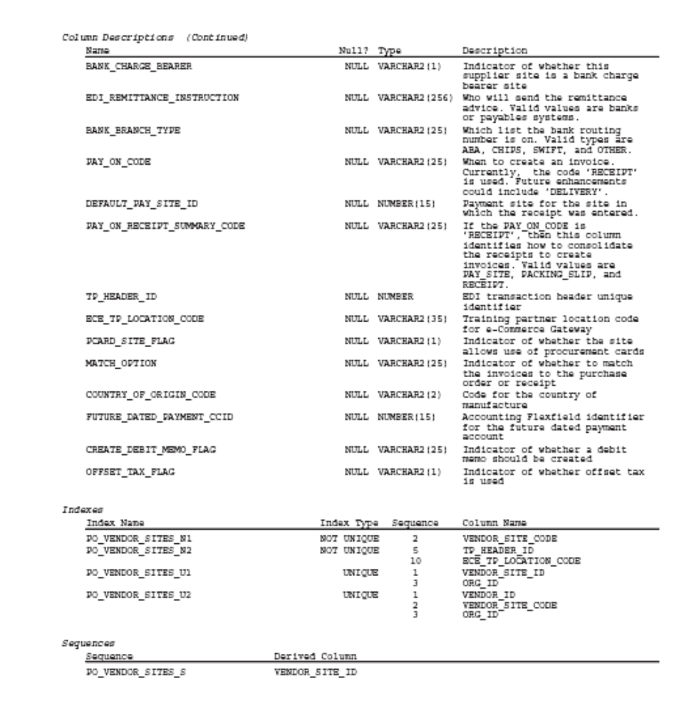
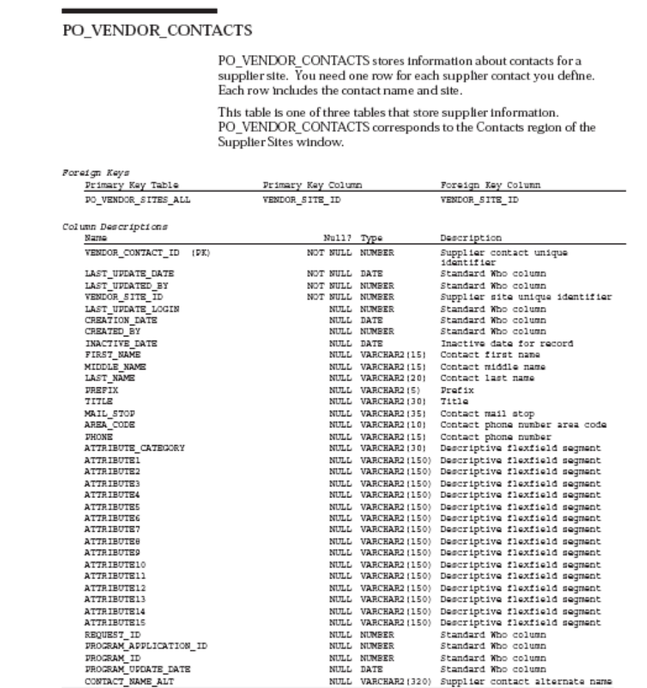

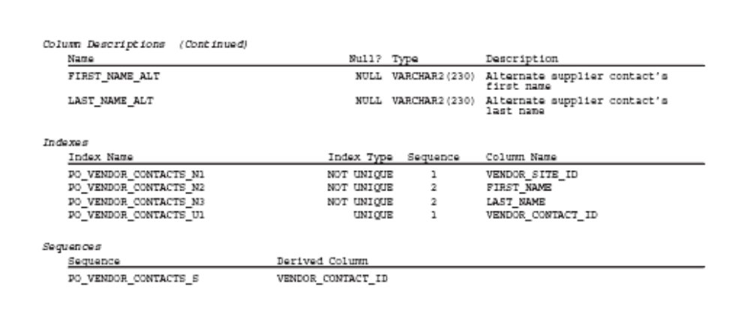

  - RIB RMS message format
See RIB Integration Guide 12011\XML_schemas for the latest formats. The schema for VendorHdrDesc and VendorAddrDesc is given below for convenience:-

Application Name: Retail Management System | Version 12.0.0 | XML-Schema or Node Name:VendorDesc.xsd

Tag Name | Table Name | Column Name | API Req | Description
VendorHdrDesc | * | * | Yes | Child node - see below.
VendorAddrDesc | * | * | Yes | Child node - see below.

Application Name: Retail Management System | Version 12.0.0 | XML-Schema or Node Name:VendorHdrDesc

Tag Name | Table Name | Column Name | API Req | Description
supplier | sups | supplier | Yes | Unique identifying number for a supplier.
sup_name | sups | sup_name | Yes | The supplier's trading name.
contact_name | sups | contact_name | No | The contact name for the supplier.
contact_phone | sups | contact_phone | No | Contact phone number for the supplier.
contact_fax | sups | contact_fax | No | Fax number for supplier.
contact_pager | sups | contact_pager | No | Pager number for supplier.
sup_status | sups | sup_status | No | A code to indicate supplier status. A = Active, I = Inactive.
qc_ind | sups | qc_ind | No | Determines whether orders from this supplier will default as requiring quality control.
qc_pct | sups | qc_pct | No | The percentage of items per receipt that will be marked for quality checking.
qc_freq | sups | qc_freq | No | The frequency for which items per receipt will be marked for quality checking.
vc_ind | sups | vc_ind | No | Determines whether orders from this supplier will default as requiring vendor control.
vc_pct | sups | vc_pct | No | The percentage of items per receipt that will be marked for vendor checking.
vc_freq | sups | vc_freq | No | The frequency for which items per receipt that will be marked for vendor checking.
currency_code | sups | currency_code | No | A code identifying the currency the supplier uses for business transactions.
lang | sups | lang | No | A code for the supplier's preferred language.
terms | sups | terms | No | A code indicating the payment terms that will default when an order is created for the supplier.
freight_terms | sups | freight_terms | No | A code indicating what freight terms will default when an order is created for the supplier.
ret_allow_ind | sups | ret_allow_ind | No | Indicates whether or not the supplier will accept returns.
ret_auth_req | sups | ret_auth_req | No | Indicates if returns must be accompanied by an authorization number when sent back to the vendor.
ret_min_dol_amt | sups | ret_min_dol_amt | No | Contains a value if the supplier requires a minimum value to be returned in order to accept the return. Stored in the supplier's currency.
ret_courier | sups | ret_courier | No | Contains the name of the courier that should be used for returns to the supplier.
handling_pct | sups | handling_pct | No | The percent to be multiplied by an order's total cost to determine the handling cost for the return.
edi_po_ind | sups | edi_po_ind | No | Indicates whether purchase orders will be sent to the supplier via Electronic Data Interchange.
edi_po_chg | sups | edi_po_chg | No | Indicates whether purchase order changes will be sent to the supplier via EDI.
edi_po_confirm | sups | edi_po_confirm | No | Indicates whether acknowledgements of purchase orders will be sent to the supplier via EDI.
edi_asn | sups | edi_asn | No | Indicates whether the supplier will send Advance Shipment Notifications electronically.
edi_sales_rpt_freq | sups | edi_sales_rpt_freq | No | This field contains the EDI sales report frequency for the supplier. Valid values are D = Daily, W = Weekly.
edi_supp_available_ind | sups | edi_supp_available_ind | No | Indicates whether the supplier will send availability via EDI.
edi_contract_ind | sups | edi_contract_ind | No | Indicates whether contracts will be sent to the supplier via EDI.
edi_invc_ind | sups | edi_invc_ind | No | Indicates whether invoices, debit memos and credit note requests will be sent to/from the supplier via EDI.
cost_chg_pct_var | sups | cost_chg_pct_var | No | Contains the cost change variance by percent. If an EDI cost change is accepted and falls within these boundaries, it will be approved when inserted into the cost change dialog.
cost_chg_amt_var | sups | cost_chg_amt_var | No | Contains the cost change variance by amount. If an EDI cost change is accepted and falls within these boundaries, it will be approved when inserted into the cost change dialog.
replen_approval_ind | sups | replen_approval_ind | No | Indicates whether contract orders for the supplier should be created in Approved status.
ship_method | sups | ship_method | No | The method used to ship the items on the purchase order from the country of origin to the country of import. Check the RMS data model for valid values.
payment_method | sups | payment_method | No | Indicates how the purchase order will be paid. Valid options are: LC (Letter of Credit), WT (Wire Transfer), OA (Open Account).
contact_telex | sups | contact_telex | No | The telex number for the supplier's contact.
contact_email | sups | contact_email | No | Contains an email address for the supplier's representative contact.
settlement_code | sups | settlement_code | No | Indicates which payment process method is used for the supplier. Check the RMS data model for valid values.
pre_mark_ind | sups | pre_mark_ind | No | Indicates whether or not the supplier has agreed to break an order into separate boxes (and mark them) that can be shipped directly to the stores.
auto_appr_invc_ind | sups | auto_appr_invc_ind | No | Indicates whether or not the supplier's invoice matches can be automatically approved for payment.
dbt_memo_code | sups | dbt_memo_code | No | Indicates when a debit memo will be sent to the supplier to resolve a discrepancy. Y = Yes, N = No, L = only if a credit note is not sent by the invoice due date.
freight_charge_ind | sups | freight_charge_ind | No | Indicates whether a supplier is allowed to charge freight costs to the client.
auto_appr_dbt_memo_ind | sups | auto_appr_dbt_memo_ind | No | Indicates whether debit memos sent to the supplier can be automatically approved on creation.
inv_mgmt_lvl | sups | inv_mgmt_lvl | No | Indicates whether supplier inventory management information can be set up at the supplier/deparment level or just at the supplier level.
backorder_ind | sups | backorder_ind | No | Indicates if backorders or partial shipments will be accepted.
vat_region | sups | vat_region | No | The VAT region for the supplier.
prepay_invc_ind | sups | prepay_invc_ind | No | Indicates whether or not all invoices for the supplier can be pre-paid invoices.
service_perf_req_ind | sups | service_perf_req_ind | No | Indicates if the supplier's services must be confirmed as performed before paying an invoice from that supplier.
invc_pay_loc | sups | invc_pay_loc | No | Indicates where invoices from this supplier are paid - at the store ('S') or centrally through corporate accounting ('C').
invc_receive_loc | sups | invc_receive_loc | No | Indicates where invoices from this supplier are received - at the store ('S') or centrally through corporate accounting ('C').
addinvc_gross_net | sups | addinvc_gross_net | No | Indicates if the supplier invoice lists items at gross cost ('G') or net cost ('N').
delivery_policy | sups | delivery_policy | No | Contains the delivery policy of the supplier. Valid values come from the DLVY code on code_head/code_detail.
comment_desc | sups | comment_desc | No | Any miscellaneous comments associated with the supplier.
default_item_lead_time | sups | default_item_lead_time | No | Holds the default lead time for the supplier. The lead time is the time the supplier needs between receiving an order and having the order ready to ship. This value will be defaulted to item/supplier relationships.
duns_number | sups | duns_number | No | The Dun and Bradstreet number of the supplier.
duns_loc | sups | duns_loc | No | The Dun and Bradstreet number of the location of the supplier.
bracket_costing_ind | sups | bracket_costing_ind | No | This field will determine if the supplier uses bracket costing pricing structures.
vmi_order_status | sups | vmi_order_status | No | Determines the status in which any inbound PO's from this supplier are created. A NULL value indicates that the supplier is not a VMI supplier.
end_date_active | * | * | No | Not used by RMS.
dsd_supplier_ind | sups | dsd_ind | No | Specifies whether or not DSD shipments can be created for the supplier.

Application Name: Retail Management System | Version 12.0.0 | XML-Schema or Node Name:VendorAddrDesc

Tag Name | Table Name | Column Name | API Req | Description
module | addr | module | Yes | Indicates the data type that the address is attached to. In this case, it will always be 'SUPP'.
key_value_1 | addr | key_value_1 | Yes | Holds the id the address is attached to. In this case, it will be the supplier number.
key_value_2 | * | * | No | Field not used.
seq_no | * | * | No | Field not used.
addr_type | addr | addr_type | Yes | The address type. Valid values (e.g. 01 - Business, 02 - Postal, etc.) are on the add_type table.
primary_addr_ind | * | * | No | Field not used.
add_1 | addr | add_1 | Yes | The first line of the address.
add_2 | addr | add_2 | No | Contains the second line of the address.
add_3 | addr | add_3 | No | Contains the third line of the address.
city | addr | city | Yes | Contains the name of the city associated with the address.
state | addr | state | No | Contains the state abbreviation for the address.
country_id | addr | country_id | Yes | Contains the country where the address exists.
post | addr | post | No | The zip code for the address.
contact_name | addr | contact_name | No | The name of the contact at this address.
contact_phone | addr | contact_phone | No | The phone number for this address.
contact_telex | addr | contact_telex | No | The telex number for this address.
contact_fax | addr | contact_fax | No | The fax number for this address.
contact_email | addr | contact_email | No | The email address for this address.
oracle_vendor_site_id | * | * | No | Field not used.
OracleOUDesc | * | * | No | Child node.

Application Name: Retail Management System | Version 12.0.0 | XML-Schema or Node Name:OracleOUDesc

Tag Name | Table Name | Column Name | API Req | Description
OUDtlDesc | * | * | No | Child node.

Application Name: Retail Management System | Version 12.0.0 | XML-Schema or Node Name:OUDtlDesc

Tag Name | Table Name | Column Name | API Req | Description
ou_id | org_unit_add_site | org_unit_id | Yes | The Oracle Financials org unit associated with this address.
site_id | org_unit_addr_site | oracle_vendor_site_id | Yes | The Oracle Financials site id associated with this address.

